Pathology classification analysis using multiple Deep Learning techniques

Aditya Shirude

Electronics and Telecommunication Engineering

Viswakarma Institute of Technology

Pune, India

aditya.shirude20@vit.edu

*Abstract*—***There is a need for automating the classification of huge pathological image data more accurately and efficiently in the medical sector. In this paper a proposed system of neural networks with Deep Belief Network for Image feature extraction and two different algorithms namely K Nearest Neighbors(KNN) and Transfer learning algorithm based on adaptive Support Vector Machine(SVM) to classify pathological images. The proposed system will provide the complete framework that is capable of processing graphical pathology images with better accuracy compared to the traditional neural network algorithms. Using said methodology we will store the results obtained in the testing of pathological images for pneumonia and the same results can be used for classifying the covid-19 images using the said methodology.***

Keywords—*Deep Belief Network, SVM, KNN, Deep learning*

# Introduction

Over the previous few a long time, the speedy population growth has made early detection of sickness an essential topic in clinical studies. Many researchers had been capable of create packages to come across and are expecting ailment the use of open-source datasets that are made available with the aid of different healthcare institutes. further, next-technology sequencing has

enabled researchers to dive deeply into the complicated info of biological systems which can be evaluated mathematically to create deep gaining knowledge of models extra correctly for class and selection purposes. The chance of loss of life from serious illnesses like cancer is growing exponentially because the population grows. A device that assists clinical personnel in sickness diagnosis, affords dependable, green, and fast response, and reduces the risk of fatalities. The proposed version is designed to enhance present day category and characteristic extraction methods in pathology photographs. The more recent transfer gaining knowledge of based technique has outperformed the traditional neural education techniques and is stated to be more correct in detecting the disorder at an in advance level. This study compares the accuracy of neural schooling strategies on various datasets to discover the satisfactory appropriate algorithm for the class of medical pix. This observe additionally objectives to automate the classification method of the pathology photographs generated by the scientific institutes more correctly in comparison to the traditional CNN strategies with the aid of using Adaptive guide Vector device-primarily based on gaining knowledge of pre-trained model to improve the results of the newly trained model.

# Literature Review

1. The purposed paper summarized the many directions for AI-based cancer prediction models. There is room for improvement in the early identification of head and neck cancers, as little research has been done on these two types of cancer due to a lack of data sets.
2. proposed that the accuracy of voice pathology systems is commonly utilized as an important criterion for evaluating them. As a result, the researchers adopted this performance assessment in this study to compare the proposed OSELM model to existing methods in vocal pathology systems that have also used voice samples from SVD.
3. The proposed study uses the Deep Belief Network, a new patch-based deep learning algorithm dubbed Pa-DBN-BC is presented to detect and classify breast cancer on histopathology images (DBN). The proposed model learns the features automatically by creating equal size patches of images. This will reduce the computational cost and also provides high accuracy in binary classification.
4. Proposed the work to address the difficulty of limited annotations in the field of computational pathology, they developed a framework for histopathology picture categorization based on self-supervision tasks. The findings suggest that pathology-specific tasks can outperform generative techniques despite being simple and easy to execute.
5. Proposed Machine learning techniques based on micro-array and NGS data have also been implemented in the proposed study. Further studies could revolve around how micro-RNAs can aid in cancer patient diagnosis and prognosis.
6. Proposed a single framework for merging radiology and pathology imaging is being investigated in this study. To make the extraction of unique features easier, regions of interest in pathology and radiology images are segregated. The images for radiology and pathology are processed using an independent image processing pipeline in this work. The images are gleaned and necessary structures suitable for the task are extracted. It is then provided as input to pre-trained Inception v3 for extraction of distinct high-level complex feature descriptors.
7. Proposed the work in which Three-dimensional CT images were used to segment cancer nodules using the DNN. The efficiency of DNN improves as the amount of training data grows. It has enhanced accuracy of 0.8119 and can be used to segment tiny lung nodules.
8. Use of segmentation approaches based on deep learning because of its ability to self-learn over large amounts of data. To segment the various tissues in an MR image of a brain tumor to help with diagnosis and other assessments. Since this manual process is difficult and time-consuming, there is a need for automated image segmentation of brain tumors.
9. The proposed Deep neural networks have been demonstrated to correctly classify gliomas up to 94% of the time. The proposed Deep learning techniques for MRI Brain registration are still in their early stages, and there is no consensus on the optimal methods. Although segmentation has gotten increasing attention, it still suffers from a lack of appropriate training data as well as data that is unbalanced.
10. The proposed study intends to use classical logistic regression, multi-factor analysis, and artificial intelligence-aided analysis. Cancer detection algorithms based on deep learning are being investigated. These tactics influence cancer diagnosis approaches and serve as a resource for clinicians.
11. The major goal of this study was to create a convolutional neural network for detecting lung tumors in X-ray pictures of the chest. To compare the results of the aforesaid CNN network with other approaches such as MLP and SVM, 225 approaches were used.
12. The proposed study intends to use attribute selection techniques and classifiers models on the Immunotherapy dataset. They observed that the classifier model worked comparatively less accurately on raw data but the same model showed very good results on the attribute selection processed model.
13. This paper presents two efficient deep transfer-learning-based models that rely on pre-trained CNNs and a wide set of ImageNet datasets. In multiclass classification, the suggested system obtained up to 98 percent accuracy, while in binary classification, it achieved 100 percent accuracy.
14. The study proposes an automatic disease detection system that can assist medical personnel by providing a reliable, effective, and efficient approach, as well as decreasing the risk of disease-related death. The best accuracy is achieved by ANNs, which is 98.57 percent, while the lowest accuracy is achieved by RFs and LR, which is 95.7 percent.
15. This study proposes a new approach for extracting features from CT pathological pictures of the brain and chest and classifying them has been developed. A semi-supervised learning approach for picture classification is proposed. Counter neural networks outperform other neural networks and standard classification methods by 10%, and the benefits are more visible.
16. Use of segmentation approaches based on deep learning because of its ability to self-learn over large amounts of data. To detect the tumors in the brain by combining a deep neural network with a probabilistic neural network. The model consisted of a two-way path with CNN and PNN techniques.

1. This work investigates different Transfer Learning approaches for transferring CNN model knowledge for clinical data extraction from cancer pathology reports. The study focuses on primary cancer locations and the extraction of topography information, which is a crucial task for cancer registries.

1. Proposed the improved deep convolutional neural network for breasts before and after compression. The distorted model was correlated by the ADCNN. In this proposed work compression forces were applied. Before and after compression, get the upgraded deep convolutional neural network for breasts.
2. This proposed model claimed that calculated accuracy can be improved by expanding the dataset, as the researchers have done here by including mass-circularity measurement in the dataset, and we discovered from statistical analysis that this quantitative measurement contributes to transparency in our conclusion.
3. Three CNN models VGG16, ResNet50, and Inception v3 are trained on ImageNet in this proposed study. Instead, we look into the significance of transfer learning. 98.23% of MIAS photos, 97.35% of DDSM images, 95.50% of INbreast images, and 96.67% of BCDR images were properly classified using the suggested framework. The model could be fine-tuned for more sophisticated pathological visual classification in the future.

|  |  |  |  |  |
| --- | --- | --- | --- | --- |
| Sr No | Summary | Datasets | Methodology/Algorithm | Challenges and Discussion |
| [1] 2021 | This Study compares different Deep Neural Network-based techniques that are used to classify Pathological images and compares different methodologies with Traditional CNN etc.  The study also concludes that in the field of cancer prediction, further study is needed. | the web of science  EBSCO  EMBASE. | This study compares different methods used in computational pathology like:  Convolutional Neural Networks   * Deep Neural Networks | This review study attempts to summarize the various directions for AI-based cancer prediction models. On that basis it concludes that that only a few data sets have been explored so far for these two types of cancer, there is room to work on early detection of head and neck cancers. |
| [2] 2021 | Machine learning approaches are critical for semi vocal pathology detection using only an audio signal in voice disorders analysis. Despite this, the majority of modern vocal pathology systems use a limited acoustic database. In other words, only one vowel, such as /a/, is used to analyse the audio signal, whereas sentences and other vowels are ignored. | SVD (Saarbrucken Voice Database) | * Mel Frequency Cepstral Coefficients(MFCC) * Online Sequential Extreme Learning Mexachine algorithm | The proposed work showed improved accuracy in detection and less execution time.As a result of the said research, it can be concluded that further work such as tuning the OLSEM classifier and selecting efficient weights is needed. |
| [3] 2021 |  |  | * Multi-layer perceptron (MLP) neural network * Deep Belief Network | The proposed model has higher gpu overhead and is very extensive in terms of hardware requirements.  The proposed methodology cannot classify different types of cancers as it uses binary classifiers.  The proposed model learns the features automatically by creating equal size patches of images. This will reduce the computational cost and also provides high accuracy in binary classification. |
| [4] 2021 | Self-supervised convolutional neural Application of deep learning algorithms to cancer diagnosis, specifically in CT/MR brain and abdomen images, mammogram images, histopathological images, and the detection of diabetic retinopathy. networks (CNNs) are used for learning generalizable and domain-invariant representations for pathology images using unlabeled data. In this framework, dubbed Self-Path, tissue classification is the primary task. | r Camelyon16 Challenge Dataset,  LNM-OSCC Dataset,  Kather Dataset | A proposed method trains the model by combining the main and pretext tasks. The framework includes a shared encoder that learns features shared by both the pretext and main tasks. Each task usually has a separate head connected to the shared Encoder and learning for all tasks is optimized simultaneously. | One of the drawbacks of the study is that the direction may have used alternative self-supervision tasks, such as forecasting the Eosin channel or a combination of Hematoxylin and Eosin after estimating the two channels instead of keeping them constant and expanding the jigmag grids to include larger and more complex puzzles for the network to solve |
| [5] 2021 | This study does analysis of different methods and techniques and how different researchers were able to design algorithms that aid in the early identification and prognosis of diseases thanks to artificial intelligence. Next-generation sequencing has aided in delving deeper into the complexities of biological systems. It has given a more accurate, efficient, and cost-effective technique. | Breast Cancer Dataset,UCI machine learning repository | The study did a comparative analysis on various standard algorithms and generic methods used in machine learning techniques.   * CNN * DNN | Instead of making a model based on microarray using microRNAs as they play a critical function in regulating the posttranslational regulation of coding genes and may increase efficiency.  Machine learning techniques based on microarray and NGS data have also been implemented in the proposed study. Although cancer research is still in its early stages, there are a number of potential areas that could benefit from recent developments in the field of anti-cancer medication prediction using machine learning, as well as how microRNAs can aid in cancer patient diagnosis and prognosis. |
| [6] 2021 | This work utilizes an independent image processing pipeline to process the images for radiology and pathology.  The work investigates a unified framework for combining radiology and pathology images.  Regions of interest in pathology and radiology images are separated to facilitate the extraction of distinct features | 2018 Computational Precision Medicine Challenge Organized by MICCAI. | The images for radiology and pathology are processed using an independent image processing pipeline in this work. The images are gleaned and necessary structures suitable for the task are extracted. It is then provided as input to pre-trained Inception v3 for extraction of distinct high-level complex feature descriptors. | Further efficiency can be achieved by dimensionality reduction techniques and eliminating features and co relations.  The performance of individual SVM classifiers trained on pathology and radiology pictures independently can be increased by using a neural network as a meta learner to merge their conclusions.  . |
| [7] 2020 | Application of deep learning algorithms to cancer diagnosis, specifically in CT/MR brain and abdomen images, mammogram images, histopathological images, and the detection of diabetic retinopathy. | Nanyang Technologıcal Unıversıty under NTU Ref: RCA-17/334 | The convolution neural network is a multi-scale neural network that consists of three convolution layers, a rectified linear unit, and a max-pooling layer, as well as two fully connected layers. The input image is downsampled, and feature extraction is performed before being delivered to the neural network. | On 3D CT images, the DNN was found to be efficient for segmenting cancer nodules. The DNN becomes more efficient as training data increases. It is accurate to 0.8119 and can segment small lung nodules.  Higher accuracy can be achieved using transfer learning and making use of pre-trained model. |
| [8] 2020 | Artificial intelligence approaches for the clinical diagnosis of brain tumors are becoming increasingly popular due to the ability of deep learning to self-learn from large amounts of data. Deep learning is a very promising and efficient approach to developing an effective solution for clinical diagnosis. | MICCAI BraTS:  T1-weightedT2-weightedT1CE-weighted  FLAIR | * Deep convolutional neural networks (DCNNs) * Auto Encoders (AEs) * Recurrent Neural * Networks (RNNs) * Generative Adversarial Networks (GANs) * Deep Neural Networks (DNNs) * Long Short Term Memory (LTSM) | The said methodology requires vast data for which  higher gpu computation is required.  The use of computer-aided systems in diagnostics has had a significant impact. Deep learning provides automatic feature acquisition which is time-efficient as compared to manual methods. There are some drawbacks too in addition to the advantages of DL and other approaches such as the cost of GPU. |
| [9] 2020 | Deep neural networks have been shown to accurately classify gliomas with up to 94% accuracy. To segment the various tissues in an MR image of a brain tumor to help with diagnosis and other assessments. Since this manual process is difficult and time-consuming, there is a need for automated image segmentation of brain tumors. | BRATS dataset of MRI scans | * Deep Learning Transformation Estimation. * Deep Learning Similarity Based Methods. * Deep Learning Network Architecture. * Transfer learning | The proposed Deep learning techniques for mri Brain registration are still in their early stages, and there is no consensus on the optimal methods. Although segmentation has gotten increasing attention, it still suffers from a lack of appropriate training data as well as data that is unbalanced. |
| [10] 2020 | The proposed study intends to use classical logistic regression, multi-factor analysis, and artificial intelligence-aided analysis; computer or software engineers and health scientists have been able to produce excellent outcomes in diagnosis thanks to advances in computer software and statistics. |  | The study does comparative analysis on the following techniques and methodologies:  Deep Neural Networks (DNN)   * Convolutional Neural Networks (CNN) * Recurrent Neural Networks (RNN) * Deep Boltzmann Machine (DBM) * Deep Belief Networks (DBN) | The application of deep learning algorithms for cancer diagnosis being investigated. These strategies lead to a shift in cancer diagnosis methods and serve as a support tool for clinicians. It has been discovered that it delivers significant advances in a critical issue like cancer treatment. |
| [11] 2020 | The research focuses on using a convolutional neural network to determine if a suspicious spot is a nodule or not. The Japanese Society of Radiological Technology (JSRT) established the JSRT digital images of the chest X-ray database. | Chest X-ray images from the medical Institute | * MLP Network * Architecture * CNN Network Architecture * Support Vector Machine | The main objective of this research was to develop a convolutional neural network for the detection of lung cancers in chest X-ray images. 225 approaches were used to compare the results of the above CNN network with other approaches such as MLP and SVM. |
| [12] 2020 | Using attribute selection techniques and classifiers models on Immunotherapy dataset.  They observed that the classifier model worked comparatively less accurately on raw data but the same model showed very good results on attribute selection processed model. | Breast Cancer Coimbra data sets | * Support Vector Machines * Random Forest * Recurrent Neural Network * Convolutional Neural Network | Further study on this model can help in analyzing the big data more efficiently.  RNN models can be used as a health tool for better and faster classification results on medical images. |
| [13] 2020 | This study proposes two effective deep transfer-learning-based models, which rely on pre-trained CNN using a large collection of ImageNet datasets. The proposed system achieved up to 98% accuracy in multiclass classification and 100% accuracy for binary classification. | ImageNet dataset  BreakHis dataset | * Transfer Learning * CNN Network | The proposed models are working less accurately in the 400x images.  This contradicts the fact that if the training data contains great detail (such as 400x breast histopathology image), the CNN network performs better. The investigation of lower accuracy in the 400x image can be another future work. |
| [14] 2020 | The study proposes an automatic disease detection system can assist medical personnel by providing a reliable, effective, and efficient approach, as well as decreasing the risk of disease-related death. | The breast cancer dataset was retrieved from the UCI machine learning repository | The study did a comparative analysis on the following algorithms:   * Support Vector Machine * K‑Nearest Neighbors * Artificial Neural Networks * Random Forests * Logistic Regression | The best accuracy is achieved by ANNs, which is 98.57 percent, while the lowest accuracy is achieved by RFs and LR, which is 95.7 percent. This concept claims that machine learning can be utilised as a clinical assistant in the identification of breast cancer because medical diagnostics is both costly and time-consuming. |
| [15] 2020 | This study proposes a new approach for extracting features from CT pathological pictures of the brain and chest and classifying them has been developed. A semi-supervised learning approach for picture classification is proposed. It uses a small quantity of tagged pathological picture data to train the network model before incorporating the network's characteristics to categorise the image. | The images used in this study are from a data center of a hospital. The database includes 12000 CT images of the brain, chest, and cervical spine. | * Support Vector Machine * Convoluted Neural Networks(CNN)   This said method uses a semi-supervised learning approach for | Counter neural networks outperform other neural networks and standard classification methods by 10%, and the benefits are more visible. Comparative investigations confirm the classification model's logic and validity, resulting in a revolutionary medical picture classification concept. |
| [16] 2020 | Combining a deep neural network with a multilayer perceptron, deep learning is utilized to detect undesirable masses in the brain. Tumors can form anywhere in the brain, and their characteristics, such as shape, contrast, and size, have remained a mystery. | Open Source MICCAI and SMIR repositories | * Convolutional Neural Network(CNN) * Probabilistic neural network( PNN) | Researchers at the University of Bristol assessed the output segmented image, as well as the accuracy and loss of the models.  According to them, the two paths CNN architecture showed better accuracy compared to other methodologies. |
| [17] 2019 | The proposed research involves analysing textual information taken from cancer pathology reports to aid in national cancer surveillance. The researchers sought to see if using a convolutional neural network for transfer learning may help with cross-registry knowledge sharing. | Independent SEER program sources; the Louisiana Tumor Registry (LA), and Kentucky Cancer Registry (KY) | * Natural language processing | This model is not generalized to classify between 2 different cancer registries even after freezing the parameters.  The study focuses on primary cancer locations and the extraction of topography information, which is a crucial task for cancer registries.  Several Transfer Learning techniques for transferring CNN model knowledge for clinical data extraction from cancer pathology reports are investigated in this paper. |
| [18] 2019 | In this proposed work compression forces were applied. Before and after compression, get the upgraded deep convolutional neural network for breasts.  The ADCNN produced a correlation of the distorted model. |  | * Multi-aspect deep convolutional neural network * Finite segment model * Recurrent neural system | The proposed framework was able to show accuracy of 87.5%.  Higher sensitivity was noted with the help of the proposed model with improvements upto 20 percent. |
| [19] 2019 | To tackle the issue of Breast Cancer among women and create a model for efficient early detection and classification the proposed work ought to use Deep learning approaches for efficient results. Deep learning has received a lot of interest in the field of categorization in recent years. In medical needs, the classification algorithm still has a lot of clouts, especially if it's combined with deep learning. | The data was provided from the Medical Center University's Institute of Oncology in Ljublijana, Yugoslavia. | * Multilayer Perceptron * Convolutional Neural Networks(CNN) | This accuracy can be improved by expanding the dataset, as it has been done here by including mass-circularity measurement in the dataset, and it is evident from statistical analysis that this quantitative measurement contributes to transparency in our conclusion. |
| [20] 2018 | Three CNN models VGG16, ResNet50, and Inception v3, are trained on ImageNet in this proposed study. Instead, we look into the significance of transfer learning. | Three different public datasets were used  The three datasets were then merged into one dataset | * Global Contrast Normalization * ROI Extraction * Transfer Learning | More difficult images show less accurate results. Using deeper models can solve this problem.  The proposed framework correctly diagnosed 98.23 percent of MIAS photos, 97.35 percent of DDSM images, 95.50 percent of INbreast images, and 96.67 percent of BCDR images.  Future work could involve fine tuning the model for more complex pathological visual classification. |

# Methodology

* *Data acquisition:-*

We will be using Kaggle Dataset for this training and testing of the model with weights from pretrained model of Vgg16 model.

Image Pre-processing:-The images will be re-sized and blurred using multiple pre-processing techniques to make them more standardized that will make testing and training easier. Vgg16 takes image of dimension 224 x 224 x 3. CNN model takes input image size of 200 x 200 x 3.

* *Algorithm implementation :-*

Using a pretrained model from Vgg16 we will use transfer learning technique to train it on our dataset. This method will reduce the total trainable parameters like in this case a total of 14,764,866 total parameters were reduced to 50,178. That will help in reducing the epoch cycles significantly and will reduce the hardware overhead. The comparison dispersion algorithm is used to update the training parameters after each parameter has been initialized and the training period and learning rate have been determined. If the algorithm converges, the output; otherwise, the parameter training as the equation continues.

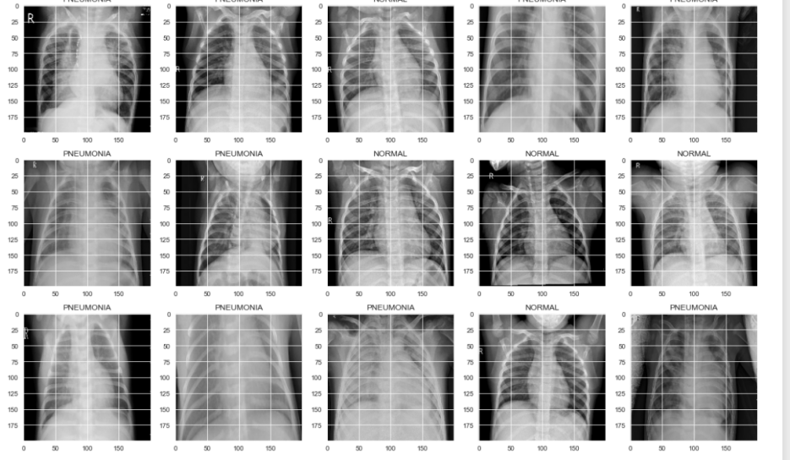

Fig(1). Head of the Kaggle dataset. Lung disease dataset from Kaggle.

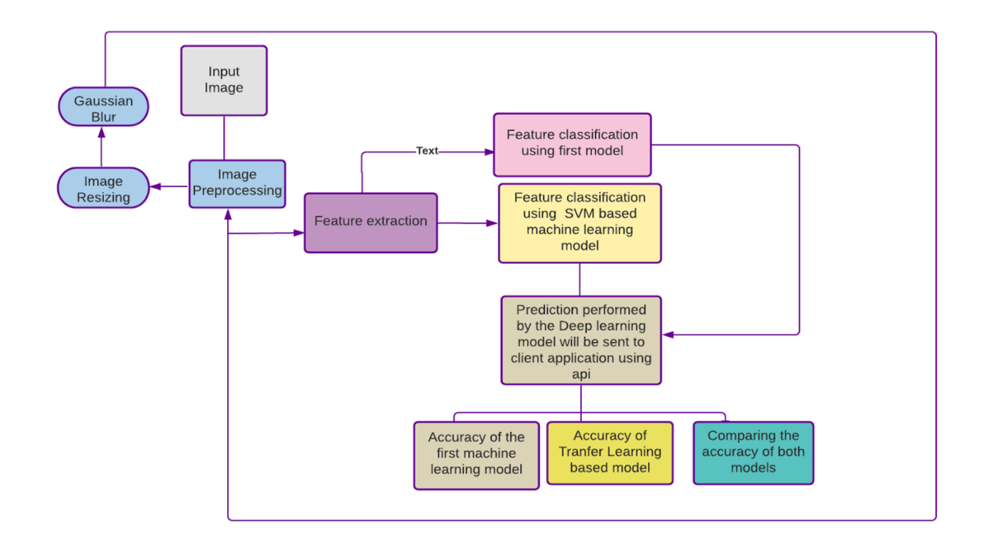

Fig(2). Working Flowchart of the proposed framework in block diagram form. The flowchart represents the working of the said algorithm in different phases.

* *Classification of Images:-*

Classification of images will be done by two different models based on different algorithms.

1)For the first model we will use Transfer learning (TL) which is a machine learning (ML) research method that works by storing the results of the particular data and then using the stored data to find the solution of related but different problems. For this method a pre-trained model is required which will be then retrained for classifying different dataset. The advantage of using transfer learning is that we already have a pre-trained dataset and retraining will take less number of epochs for achieving higher accuracy levels. This will save a considerable amount of computational power and result in a more efficient model. Using said methodology we will store the results obtained in the testing of pathological images for pneumonia and the same results can be used for classifying the covid-19 images using the said methodology.

2)The second model uses supervised machine learning, where H. is taught by recording the input X and the label Y, and then learning how to map input X to output Y. Using this method, we can arrange the images in 2D vector space, calculate their distance between each other, and then sort them. We now will pick up the minimum distance and assign them a label. The results produced by the models will be compared on a scale of 0 to 1 for accuracy.

1. The first model will use the Vgg16 State of the art framework to train the dataset. We will use “adam” as a optimizer. The model will predict categorical variable. The Transfer learning model will have will intake the input as 224 by 224 as the vgg16 was made in such a way. The second model will be a CNN based which makes use of uses sklearn package of python and also a categorical variable predictor.

# Results

The Transfer learning model showed an accuracy of accuracy: 0.9714 total of 5 epoch cycles. The model showed significantly improved results in reducing the computational overhead and giving so much accurate results.

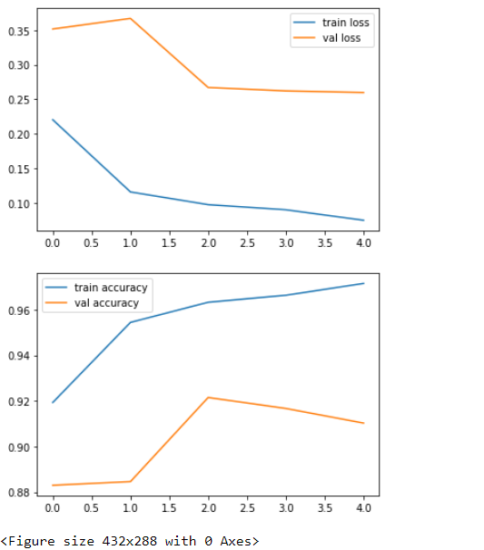

Fig(3). Plot of val accuracy, val loss,

train accuracy, train loss.

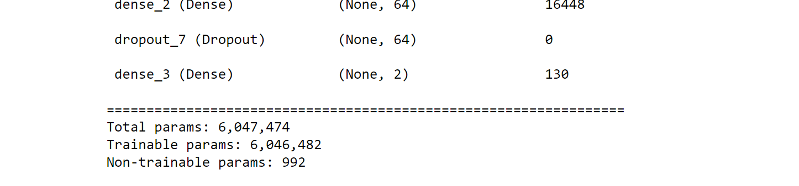

Fig(4). Parameters of TL Model

The CNN model showed an accuracy of 77.24 percent in 20 epoch cycles. With over 600000 parameters to train it took quite a bit of hardware power to train it in a relatively high number of epoch cycles.

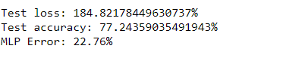

Fig(5) Accuracy of CNN model

# CONCLUSION:

As shown in results the Transfer Learning Model showed an accuracy of 97.14 or 0.9714. The accuracy of CNN Model was 77.24 as showed in results in 20 epoch cycles. The proposed paper is still in its early stages and as the current technology progresses there will be many different ways to approach this kind of data more efficiently. The further improvement in hardware can also be a very useful step in increasing the accuracy and reducing the time complexity for training such models. The pathology images are very important for the detection of fatal diseases and disorders. And therefore it is very important to have an automated efficient system that can be used for such tasks. To tackle the ever-increasing demand for a computationally efficient and accurate framework that can cope up with the ever-increasing pathological image that is produced in recent times the proposed model intends to create a structured framework. The proposed model uses the Support Vector Based Transfer Learning model for more accurate results compared to the traditional CNN methods and techniques. To check and analyze the efficiency of the model we compared it with a traditional CNN classifying method.

# FUTURE SCOPE:

Implementing the pre-trained model to predict more complicated medical imagery like tumors prediction from ct-scans images. The model can be trained so that it can be used to precisely located possible tumor growth to catch the disease in very early stages. The scope of computer vision combined with deep learning is very vast and can be only explored if we make new and more innovative techniques from current available architecture.

##### References

1. Kumar, S. N., Fred, A. L., Padmanabhan, P., Gulyas, B., Kumar, H. A., & Miriam, L. J. (2021). Deep Learning Algorithms in Medical Image Processing for Cancer Diagnosis: Overview, Challenges and Future. *Deep Learning for Cancer Diagnosis*, 37-66.
2. Al-Dhief, F. T., Baki, M. M., Latiff, N. M. A. A., Malik, N. N. N. A., Salim, N. S., Albader, M. A. A., ... & Mohammed, M. A. (2021). Voice Pathology Detection and Classification by Adopting Online Sequential Extreme Learning Machine. *IEEE Access*, *9*, 77293-77306.
3. Hirra, I., Ahmad, M., Hussain, A., Ashraf, M. U., Saeed, I. A., Qadri, S. F., … Alfakeeh, A. S. (2021). Breast Cancer Classification From Histopathological Images Using Patch-Based Deep Learning Modeling. IEEE Access, 9, 24273– 24287.
4. Koohbanani, N. A., Unnikrishnan, B., Khurram, S. A., Krishnaswamy, P., & Rajpoot, N. (2021). Self-Path: Self-supervision for Classification of Pathology Images with Limited Annotations. *IEEE Transactions on Medical Imaging*.Self-Path: Self-supervision for Classification of Pathology Images with Limited Annotations. IEEE Transactions on Medical Imaging.
5. Sharma, A., & Rani, R. (2021). A Systematic Review of Applications of Machine Learning in Cancer Prediction and Diagnosis. *Archives of Computational Methods in Engineering*, 1-22.
6. Rajalakshmi, N. R., Sangeetha, B., Vidhyapriya, R., & Ramesh, N. (2021). Combined Radiology and Pathology Based Classification of Tumor Types. In Deep Learning for Cancer Diagnosis (pp. 99-109). Springer, Singapore.
7. Kumar, S. N., Fred, A. L., Padmanabhan, P., Gulyas, B., Kumar, H. A., & Miriam, L. J. (2021). Deep Learning Algorithms in Medical Image Processing for Cancer Diagnosis: Overview, Challenges and Future. *Deep Learning for Cancer Diagnosis*, 37-66.
8. Munir, K., Frezza, F., & Rizzi, A. (2021). Deep Learning for Brain Tumor Segmentation. In *Deep Learning for Cancer Diagnosis* (pp. 189-201). Springer, Singapore.
9. Healy, J. J., Curran, K. M., & Trbalic, A. S. (2021). Deep Learning for Magnetic Resonance Images of Gliomas. In *Deep Learning for Cancer Diagnosis* (pp. 269-300). Springer, Singapore.
10. Calp, M. H. (2021). Use of Deep Learning Approaches in Cancer Diagnosis. In *Deep Learning for Cancer Diagnosis* (pp. 249-267). Springer, Singapore.
11. Deepal, D. A. A., & Fernando, T. G. I. (2021). Convolutional Neural Network Approach for the Detection of Lung Cancers in Chest X-Ray Images. In *Deep Learning for Cancer Diagnosis* (pp. 203-226). Springer, Singapore.
12. Basarslan, M. S., & Kayaalp, F. (2021). Performance evaluation of classification algorithms on diagnosis of breast cancer and skin disease. In *Deep Learning for Cancer Diagnosis* (pp. 27-35). Springer, Singapore.
13. Yari, Y., Nguyen, T. V., & Nguyen, H. T. (2020). Deep learning applied for histological diagnosis of breast cancer. *IEEE Access*, *8*, 162432-162448.
14. Islam, M. M., Haque, M. R., Iqbal, H., Hasan, M. M., Hasan, M., & Kabir, M. N. (2020). Breast cancer prediction: a comparative study using machine learning techniques. SN Computer Science, 1(5), 1-14.
15. Tang, H., & Hu, Z. (2020). Research on medical image classification based on machine learning. IEEE Access, 8, 93145-93154.
16. Madhupriya, G., Guru, N. M., Praveen, S., & Nivetha, B. (2019). Brain Tumor Segmentation with Deep  Learning Technique. 2019 3rd International Conference on Trends in Electronics and Informatics (ICOEI)
17. Alawad, M., Gao, S., Qiu, J., Schaefferkoetter, N., Hinkle, J. D., Yoon, H. J., ... & Tourassi, G. (2019, May). Deep transfer learning across cancer registries for information extraction from pathology reports. In 2019 IEEE EMBS International Conference on Biomedical & Health Informatics (BHI) (pp. 1-4). IEEE.
18. Ahmed, S. R. A., UÇAN, O. N., Duru, A. D., & Bayat, O. (2018). Breast cancer detection and image   evaluation using augmented deep convolutional neural networks. *Aurum journal of engineering systems and architecture*, *2*(2), 121-129.
19. Nurmaini, S., Malik, R. F., Abidin, D. Z., Zarkasi, A., & Kunang, Y. N. (2018, October). Breast cancer classification using deep learning. In *2018 International Conference on Electrical Engineering and Computer Science (ICECOS)* (pp. 237-242). IEEE.
20. Chougrad, H., Zouaki, H., & Alheyane, O. (2018). Deep convolutional neural networks for breast cancer screening. *Computer methods and programs in biomedicine*, *157*, 19-30.